

USBASP FLASHING TUTORIAL -BY SCOU

You can use a usbasp programming chip to flash your Anet Board- you can flash. Hex firmware files in avrdudes and you can burn bootloader and flash firmware in Arduino ide using this tool and this guide.

**Connecting your usbasp to your computer**

1. Connect your usbasp to you anet board using the 10-6pin adapter so that the pin names on the adapter match up to the pin names below (middle 6 pins on the j3 port)

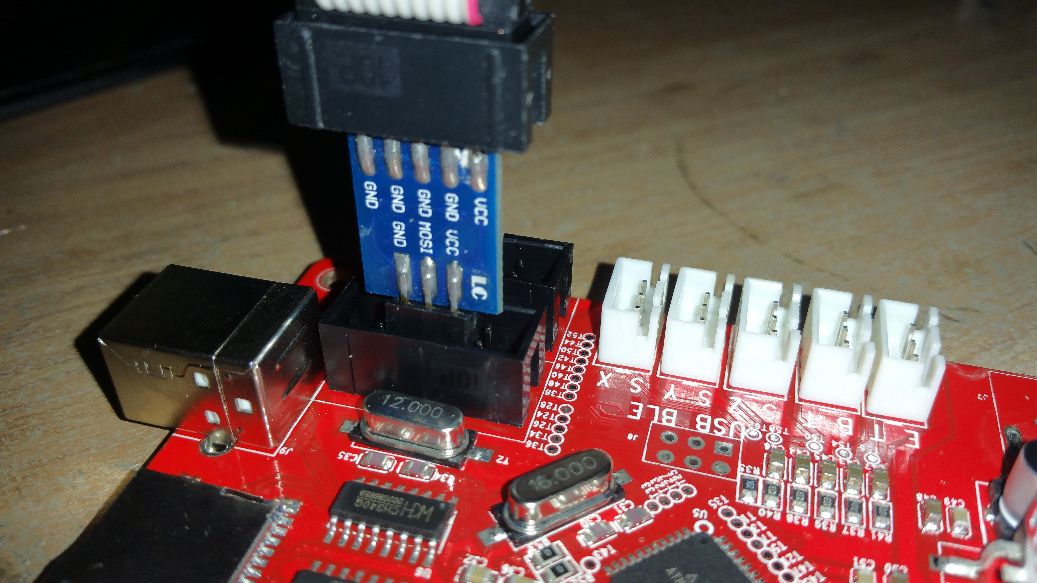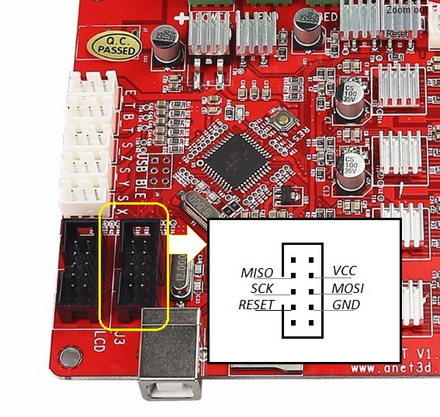

1. Connect the usbasp chip into a free port on the computer -this will now power your anet board so no need for 12v power for this process.
2. Plug in the usb cable for your anet board

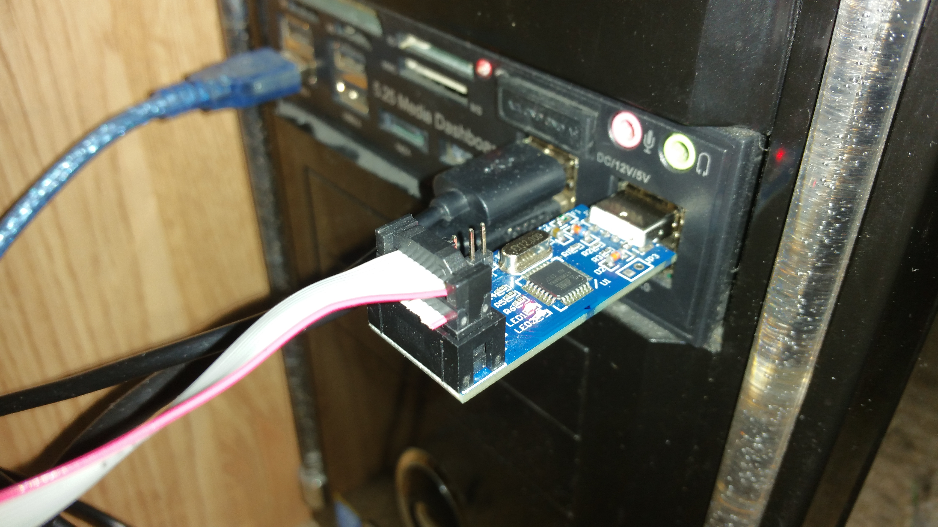

**Bootloader Flashing/ unbricking your device**

1. Open Arduino IDE (MUST BE THE ONE INCLUDED WITH SKYNET)
2. Go to ‘tools’ – select ‘Anet V1.0’
3. Select ‘’USBASP’’ as the programmer
4. Hit ‘’burn bootloader’’
5. When it says ‘’Done burning bootloader.’’ That’s it job done.. you’ve just burned the bootloader section of the chip with the stock anet bootloader – now your device will allow you to flash as normal using the 12v power -usb cable- and ‘AVRISP mkii’’ programmer setting.

**Flashing firmware using usbasp**

Once you have flashed the bootloader as stated above you can go right ahead and configure your firmware and hit ‘’upload’ to flash that firmware to your board using the usbasp

You can also use avrdudess to flash the stock .hex firmware- the stock firmware are located in the troubleshoot folder of the Skynet3d firmware download

1. Select ‘’Usbasp’’ as programmer
2. Select ‘’ATmega1284p’’ as the ‘’MCU’’
3. Select ‘’usb’’ as the port
4. Load the desired .hex firmware into the ‘’Flash ‘’ section
5. Hit ‘’Go’’

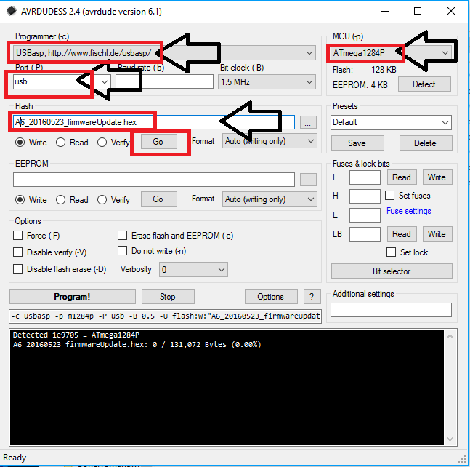

When it says done in the black window then its done!

Congratulations- you’ve just unbricked your board.. wasn’t so hard was it?? ;)